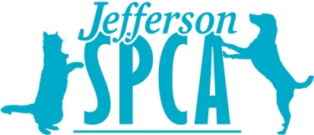
HELP THE HOMELESS KITTENS OF JEFFERSON PARISH

WISH LIST ITEMS:
Fancy Feast Kitten Wet Food
Royal Canin Mother & Baby Cat
Wet & Dry Food

Royal Canin Kitten Wet & Dry Food

1mL syringes without needles (Caps are appreciated)
Cat Toys
Dawn Dish Soap
Cat Treats
Purell Hand Sanitizer
Tidy Cats Clay Litter
KMR Powder
Tiki Cat Baby & Thrive Food/Supplements

GIFT CARDS TO:
Amazon, Jefferson Feed, Petco, PetSmart & Wal-Mart

THANK YOU FOR YOUR HELP!
WWW.JEFFERSONSPCA.ORG
Facebook.com/JeffersonSPCA
4421 Jefferson Hwy.
Jefferson, LA 70121

